2020 Scholarship Application
ABOUT
Rehab Knowledge Advantage is seeking to expand access to our library of American Board of Physical Therapy Specialties exam preparation courses by offering scholarships for the NCS Advantage, OCS Advantage, and PCS Advantage. One winner will be selected for each course.
HOW TO APPLY
Submit the attached application by email to scholarship@rehabknowledge.com by 11:59pm Central on October 3. Winners will be notified by October 17.
NOTE
This is a competitive process and all applications will be reviewed by a selection committee. A rubric is used to ensure fair rating of applicants based on criteria set in the application. By submitting your application, you agree to allow Rehab Knowledge Advantage to share your name on our website and social media platforms if you are selected as a recipient of one of our scholarships.

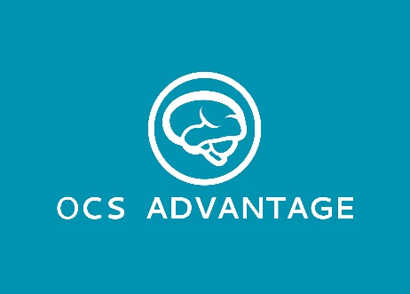
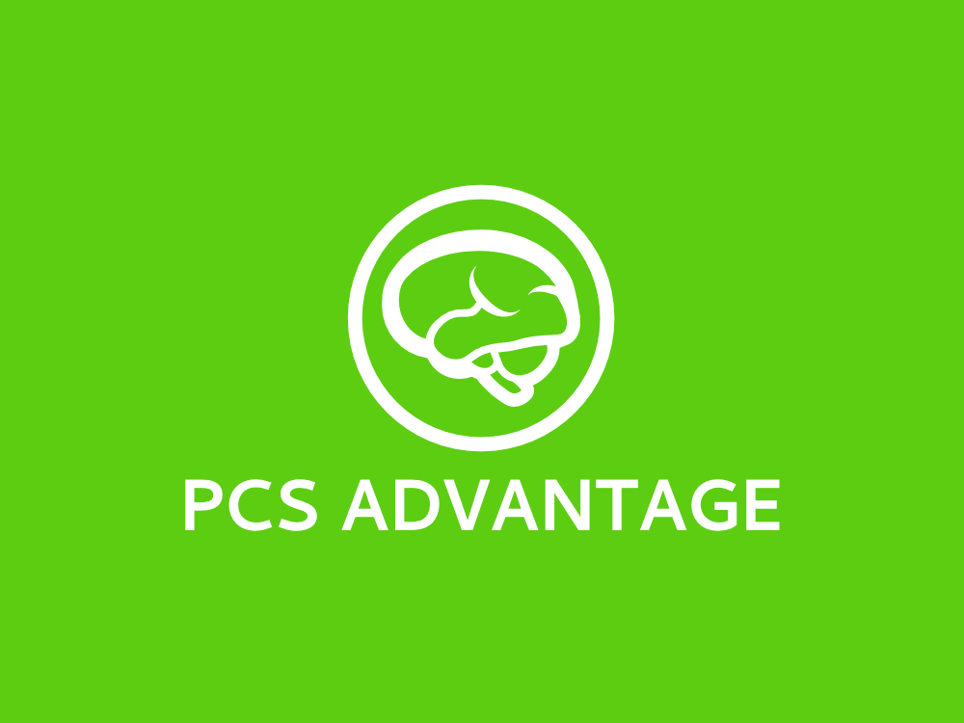
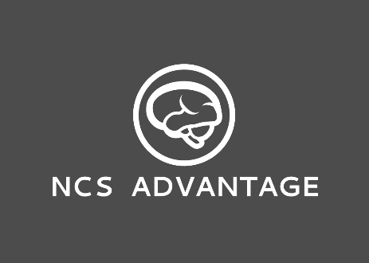

 | Scholarship Application
Section I: Applicant Information
Name: | Employer:
Email: | Do you receive CEU funding from your employer?  If yes, how much per year? $ .
State:
Please check all boxes that apply:
Section II: Scholarship Proposal
Course applying for:
Testing Date: | How did you hear about Rehab Knowledge Advantage?
Please answer the following questions in approximately 100-150 words each:
1. How will earning your NCS, OCS, or PCS assist you in meeting your career goals?
2. What is your biggest concern entering this process?
3. What specific problems do you believe a Rehab Knowledge Advantage course will help you solve?
4. What do you value most when evaluating potential study aids or courses?
5. How do you envision a Rehab Knowledge Advantage course will complement your study plans?
6. Why should we choose you for one of these scholarships?

Applicant Signature: | Date:

